Mapping the industrial base for the new energy economy: predicting competitiveness in clean energy economic opportunities
Ishana Ratan, Jonas Goldman, Becky Han, Benjamin E Bagozzi, Tim Sahay, and Bentley Allan

Abstract: Countries are designing green industrial policies to upgrade their economies and position their firms in global value chains. If successful, these strategies could generate cost declines, locking in decarbonization pathways with new energy technologies. However, there are two central risks. First, countries could make investments in sectors where they are unlikely to be competitive. Second, poor quality information about economic opportunities could lead several countries to compete in a small number of technologies. Countries must diversify investments and compete in their areas of strength, but this requires granular tools to map capabilities and opportunities. In this paper, we identify the priority sectors for investment across countries. We present a machine learning model that predicts country competitiveness across 10 clean energy technologies. The model also specifies the parts of countries' industrial base that drive competitiveness in each area and demonstrates that each country has a unique profile that shapes its competitiveness. The model enables countries to identify both existing strengths and provides pathways for building future capabilities in specific industrial areas.

Keywords: industrial policy; industrial base; green comparative advantage; exports; machine learning; global value chains

Introduction
Countries all over the world are designing green industrial policies to upgrade their economies and position their firms in global value chains. The success of China’s industrial strategy for wind, solar, and batteries has spurred action in both developing and developed countries. Focused investment and coordination in China and elsewhere drove down the cost of these technologies such that they are now competitive with conventional energy incumbents. Now there is competition across a range of technology verticals including heat pumps, electrolyzers, permanent magnets, biofuels, nuclear, geothermal, and transmission equipment. If successful, these strategies could generate cost declines, locking in decarbonization pathways with new energy technologies.
However, there are two central risks. First, countries could make investments in sectors where they cannot be competitive. Countries pursuing green industrial policy must recognize that competitive advantage in high technology areas can be built over time, as China’s example shows, but is not infinitely elastic in the short-term. Thus, industrial strategies are more likely to be successful if they build upon existing strengths while charting pathways into new areas.
Second, poor quality information about the industrial base required to produce a technology and global landscape of competition will lead many countries to compete in a small number of technologies. For example, in 2020 and 2021, many countries announced hydrogen or solar manufacturing strategies. This strategic concentration can create real problems for developing countries, as overinvestment in coffee and other commodities did in the 1960s. Rising production pushed down prices, and exposed many countries’ bets.
Instead, countries need to diversify and compete in their areas of strength. As Nahm has shown, clean energy technologies are built on complex global divisions of labor in which countries develop niche comparative advantages rooted in their economic institutions. This means that countries’ opportunities are likely to be far more specific than policymakers may think, requiring granular tools to map capabilities and opportunities.
For both these reasons, countries need rigorous analytics and strategy to support industrial policy design. In this paper, we seek to help countries address a central problem: what are the priority sectors for investment? This in turn raises deeper questions. What are the countries’ comparative advantages? What capabilities does the country possess that could transform into comparative advantages?
A number of studies have set out to identify opportunities. The seminal work of Hausmann and Hidalgo on economic complexity argues that countries should seek to develop capabilities in products that are related or adjacent in the product space to their current exports. At the core of their approach is the idea that economies possess knowledge and skills that are not easy to acquire.
This is consistent with in-depth qualitative work on manufacturing and innovation clusters. Berger and her collaborators argue that successful industries emerge from dense interactions between the lab and the factory floor because only those interactions can build the knowledge needed to sustain advanced industries.
Rosenow and Mealy, building on earlier work by Mealy and coauthors, create indices to assess countries’ decarbonization technology strengths and opportunities. They follow Hausmann and Hidalgo in arguing that countries have opportunities in areas where their current capabilities align with their current revealed comparative advantage profile.
In this paper, we build on the critical insights of this work to develop a machine learning model that predicts country competitiveness across 10 clean energy technologies. Consistent with the approaches above, we build the model on global export data because it provides the granularity necessary to map capabilities. Our model used three sets of independent variables: revealed comparative advantage in products in the supply and process chains for each technology, the co-exports for these products, and a slate of country characteristics (including GDP, manufacturing as a percentage of GDP, etc.).
We used a random forest classification model to predict competition in the final product for each technology vertical. The strength of a random forest model is that unlike other strategies, it is broadly inductive and does not require us to make strong assumptions about what will predict competitiveness in final product. Moreover, it offers an interpretable approach that allows us to identify the most important predictors of competitiveness.
We find that advanced economies including China, Japan, Korea, Germany, and the United States are competitive across many verticals. But there are many opportunities for emerging markets and developing economies (EMDE) with India, Malaysia, Thailand, Philippines, Turkey, and Mexico exhibiting particular strength. The model can support countries’ strategic focus by highlighting granular capabilities, which can lay the foundations for diversifying investments and competing in a range of sectors.
Moreover, it provides a non-mechanical view on how countries should think about industrial strategy. A simple, low-risk strategy to compete in each vertical is to build the industrial base in the underlying areas necessary for that technology. This finding is consistent with seminal and recent findings in the literature on industrial strategy that highlight the importance of investments in the upstream industrial base. Korea, for example, transformed itself into a modern manufacturing and chemicals powerhouse by strongly subsidizing upstream metal and chemical production and allowing the benefits to flow downstream.
A key finding of our models is that five sets of capabilities are critical for predicting country competitiveness: electronics, machinery, mining and metals, industrial materials, and chemicals. Moreover, each technology has a unique profile corresponding to the kind of industrial base needed to be competitive. For example, solar competitiveness is driven primarily by strength in metals (e.g. mounting structures for solar arrays) and chemicals, while battery competitiveness is driven by strength in machinery and chemicals.

Methodology
We use a random forest classification model to evaluate the determinants of competitiveness across our 10 clean technologies. We provide an overview of the key independent and dependent variables before turning to model parameters and results.
We draw upon BACI trade data to calculate our key export measures. The dependent variable is a binary indicator of 1-0 if a country has revealed comparative advantage (RCA) over one, meaning that it exports more than its “fair share” of a product. Most countries do not have a high RCA in each product, so a binary dependent variable is appropriate as it somewhat mitigates issues of class imbalance. Table 1 reports the HS code we use for the dependent variable, the means of RCA in each dependent variable, and percent of nonzero values for our binary dependent variable.
Table 1. Dependent variables summary information by technology.
Technology | HS Code | Mean RCA | Percent RCA > 1
Solar | 854140, 854142,  854143 | 0.26 | 5.87
Wind | 80231 | 0.56 | 4.85
Batteries | 850760, 850780 | 0.22 | 4.92
Electrolyzers | 854330 | 0.32 | 7.89
Heat Pumps | 841861, 841581 | 0.44 | 14.01
Permanent Magnets | 850511, 850519 | 0.27 | 5.10
Nuclear | 840110, 840140 | 0.30 | 6.27
Biofuels | 220710, 220720 | 2.15 | 21.38
Geothermal | 840681, 840682 | 0.40 | 13.09
Transmission | 850431, 850432, 850433, 850434 | 0.69 | 20.80

To construct our independent variables, we calculate countries’ revealed comparative advantage in products along the supply chain, following Rosenow and Mealy. In a critical difference between our model and others, we also include RCA scores in what we call the process chain. This includes technologies needed to make each part of the supply chain. For example, in batteries we include both the HS code for cathode active material and the copper foil and mixers used to transform cathode active material into a slurry which is then sprayed on the foil. In doing so, we ensure that our model captures not only exports in the supply chain, but also the capital goods needed to produce the technologies. We provide a detailed account of our supply chain mapping process in Supplemental Information Section Table SI.1.
Our machine learning approach also allows us to include products similar to product and process equipment. We calculate the co-export probability of these products include all additional products with a minimum co-export probability greater than 0.6, following Hausman and Hidalgo. We summarize the number of supply chain components and proximate products by technology in Appendix Table A.1.

Results
The model presents three kinds of results. First, a ranking of all countries by predictive competitiveness across the 10 technologies. Second, a list of the products driving competitiveness in each sector. Third, a mapping of the industrial base for each technology.
The model predicts a countries’ likelihood of export competition in each technology. Figure 1 visualizes predicted competitiveness for the top 20 countries in wind, solar, and batteries as of 2023; we include rankings for each of the top 20 countries in Supplemental Information Section Figures SI.11- SI.17.

Figure 1. Top 20 countries by predicted competitiveness across solar, wind, and batteries.

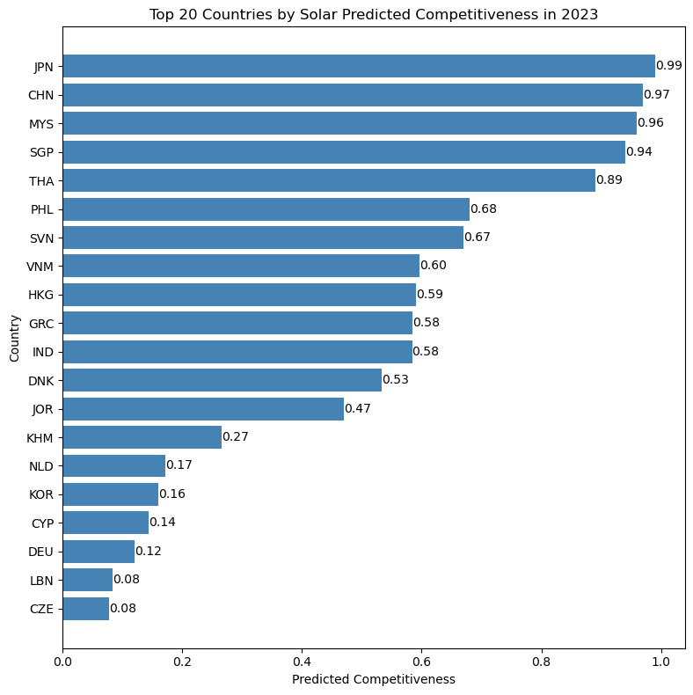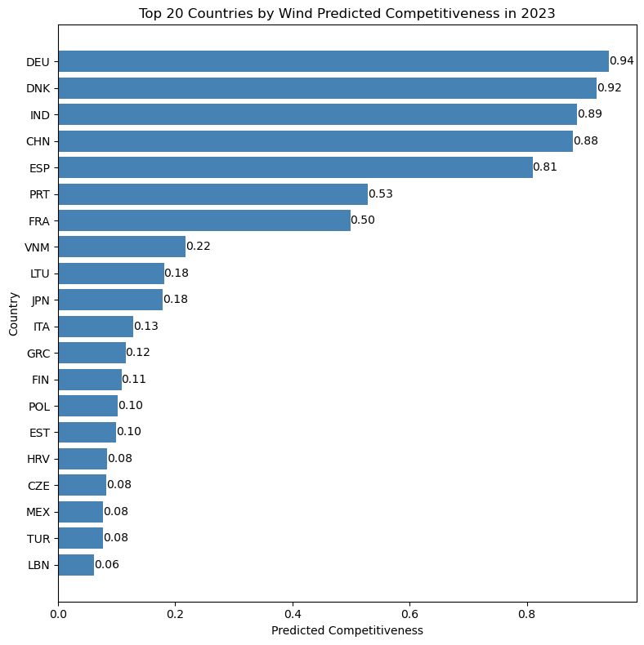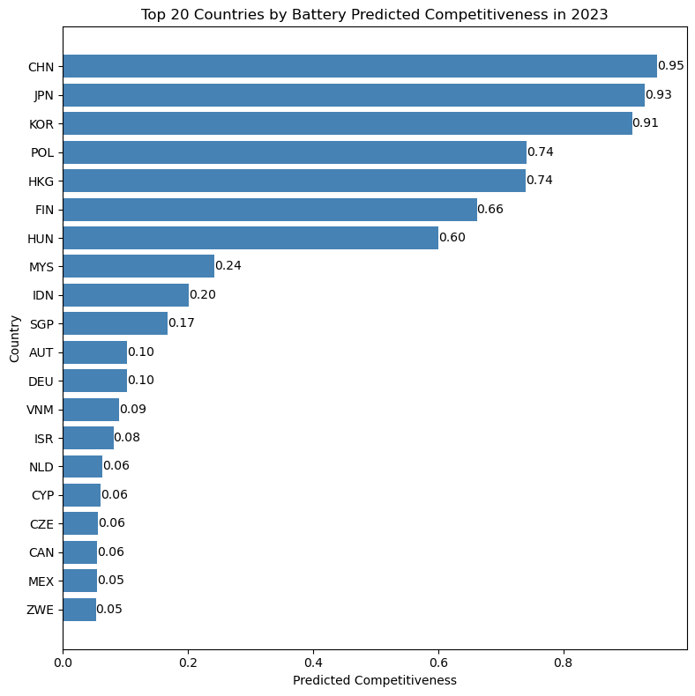

The random forest models exhibit high out of sample classification after tuning via cross-validation, which we report in Appendix Table A.2. In terms of face validity, the models also perform well in that they identify countries that are well-established leaders. For example, in solar, the model identifies China and Southeast Asian states which have received Chinese solar manufacturing foreign direct investment (FDI) as lead exporters.

Second, the model provides a granular assessment of what drives competitiveness for each technology and country. To do this, we calculate SHAP (SHapley Additive exPlanations) values for all predictors included in our final, trained random forest models. These values identify each predictor's relative importance to predictive competitiveness. We focus on the predictors with the highest SHAP values, standardized using the mean absolute value of z-scores, to identify which variables most strongly shape competitiveness. Our methodology for selecting the most important features is discussed in Appendix Section A.3, and a detailed discussion of our SHAP value calculation methodology in Appendix Section A.4.
These values reveal that each technology has a unique set of capabilities that predict competitiveness. The figure below illustrates the top products that predict competitiveness, as measured by the mean absolute z-score of SHAP values, in batteries. Bars are color coded by category of technology.
Battery competitiveness is primarily driven by machinery and chemicals. This includes not only components in a battery like machine tools for bending, but related products like machine tools for shearing that are not in the battery supply chain. However, as shown in Supplementary Information Section Tables SI.15-SI.24, the features driving competitiveness in other technologies vary considerably in both magnitude and by technology type.
Figure 2. The industrial base for batteries by product type
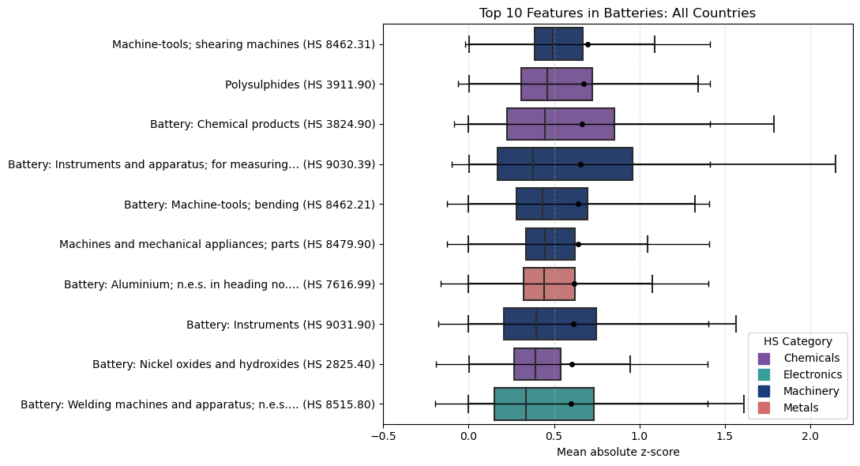This suggests that strength in the immediate supply and process chain is not a necessary condition for success in each technology. The implication is that competitiveness emerges from something deeper. To make sense of this intuition, we classified the leading predictors via SHAP values according to the groups of HS code chapters. We sum the values within each category to develop a snapshot of a technology’s industrial base.

The classification of predictors shows that clean energy industrial capabilities cluster into five capability areas: electronics, machinery, industrial materials, mining and metals, and chemicals. Interestingly, automotive and textile capabilities are almost irrelevant. We expected capabilities in these sectors to be predictive, especially since textiles are a bridge to higher value manufacturing.
Moreover, each technology has a particular profile. Solar competitiveness is driven by strengths in metals, chemicals, and electronics, while batteries are shaped by machinery, chemicals, and to a much smaller extent, electronics and metals. Figure 3 provides a visualization of the importance of features for solar (left) and batteries (right) to visualize the differences in the industrial base. This variation is an intuitive but powerful finding. Solar panels are complex electronic and metallic devices attached to glass. Batteries require complex machinery and chemical expertise to perfect metals performance. The model reflects these differences in capabilities.
Figure 3. The industrial base for solar and batteries by product type.
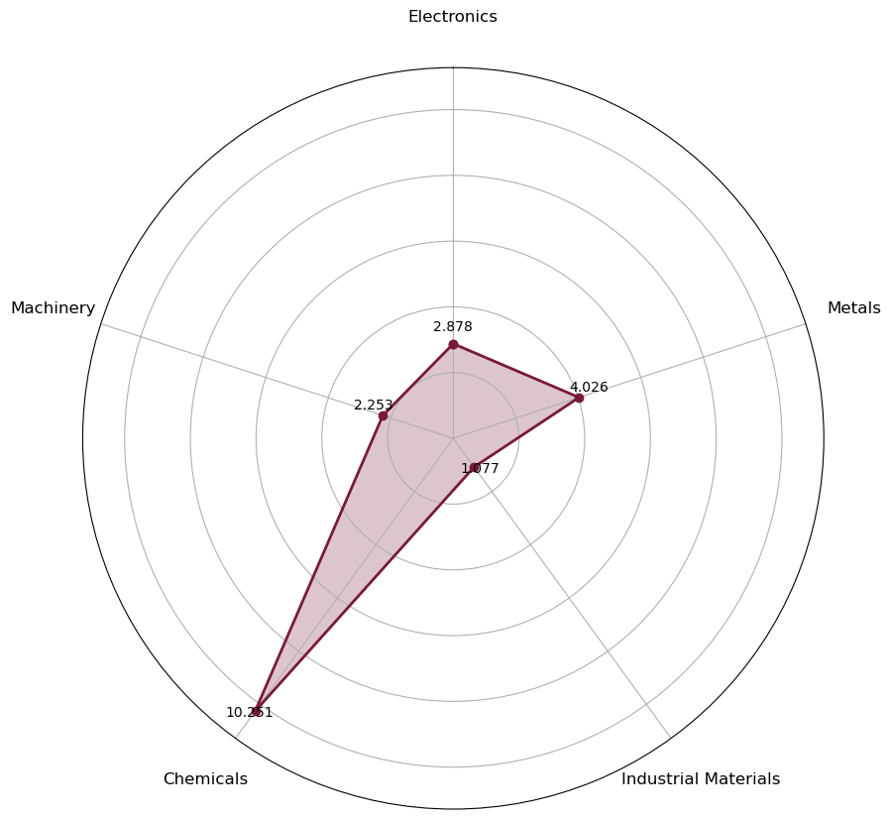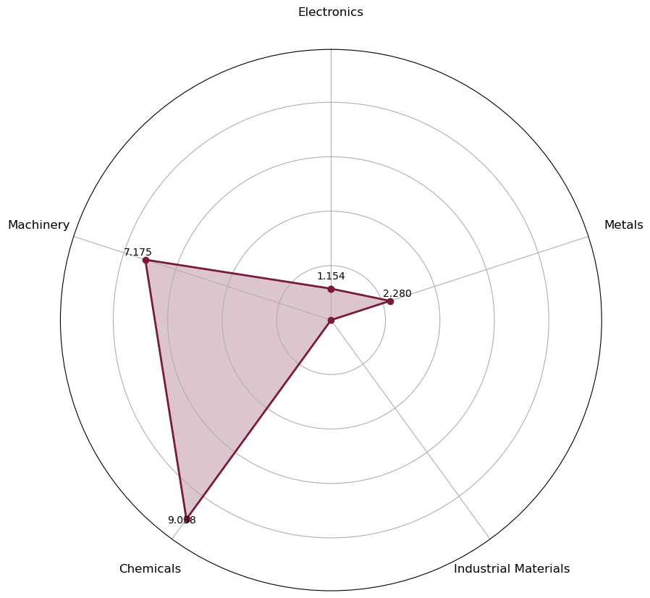

Note: In this HS code system, 84, 86-89, and 90-99 are categorized as machinery; 28-40 as chemicals; 44-49 and 68-70 as industrial materials; 25-27 and 71-83 as metals; 50-67 as Textiles, and 85 as electronics.
The result is a parsimonious mapping of the global industrial base for clean energy technology that outlines the capabilities needed to be competitive. With this characterization of the industrial base in hand, the industrial base of each country can also be mapped in a simple way. Based on the features which are most predictive of competitiveness, we calculate revealed comparative advantage to map countries’ industrial base. Figure 4 provides an example of this approach, illustrating the differences in Hungary (left) and Mexico’s (right) industrial base for batteries.
Figure 4. Battery Industrial Base, Hungary (left) versus Mexico (right)
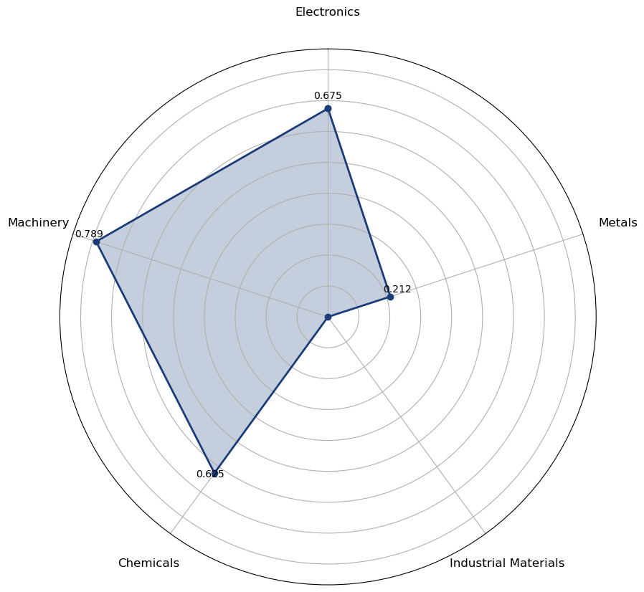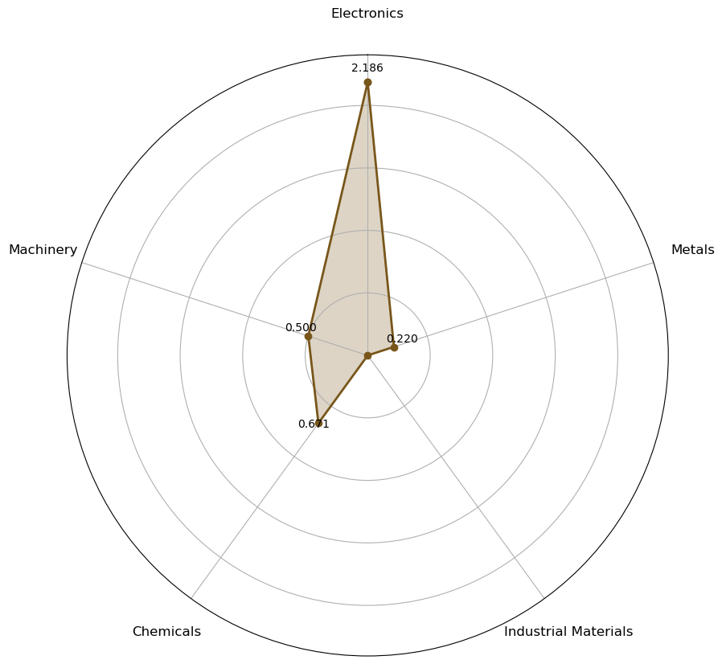

Hungary, one of the most competitive countries in battery, has a much stronger industrial base than does Mexico, which ranks significantly lower in battery export competitiveness. While Mexico has some capabilities in machinery, it lacks the chemicals expertise that drives battery competitiveness. On the other hand, Hungary’s RCA is much closer to 1 across chemicals, machinery, and electronics. This model gives countries a sense of their current strengths and enables them to map progress over time.

Discussion
The rankings of predicted competitiveness highlight the strength of the world’s industrial giants: China, Japan, Korea, and Germany across a wide range of opportunity areas. The United States has strengths in geothermal, electrolyzers, nuclear, and biofuels, but for its size it lags far behind its peers. Denmark, Italy, Spain, and France also emerge as strong competitors alongside a range of smaller European countries. The industrial base for clean energy is highly concentrated in Asia and Europe.
However, many emerging markets and developing economies also demonstrate broad strengths. India scores highly on average, with good competitiveness in solar, wind, magnets, nuclear, and biofuels. This suggests that its recent manufacturing push has been more successful than many realize and that U.S. investments in India may be well-placed to generate long-term supply chain diversification. Outside of the top 20, Thailand, Turkey, and Mexico all have strong overall rankings.
However, the point of this model is not to rank overall strengths, but allow countries to identify areas of competitive advantage so that they can make smart industrial strategy investments. Consider Figure 5, which summarizes competitiveness across all areas for a number of countries. Here the lesson is not that Malaysia, the top ranked EMDE country, is a powerhouse, but that it has particular strengths in solar, magnets, and transmission.
Figure 5. Technology competitiveness in selected countries, 2023
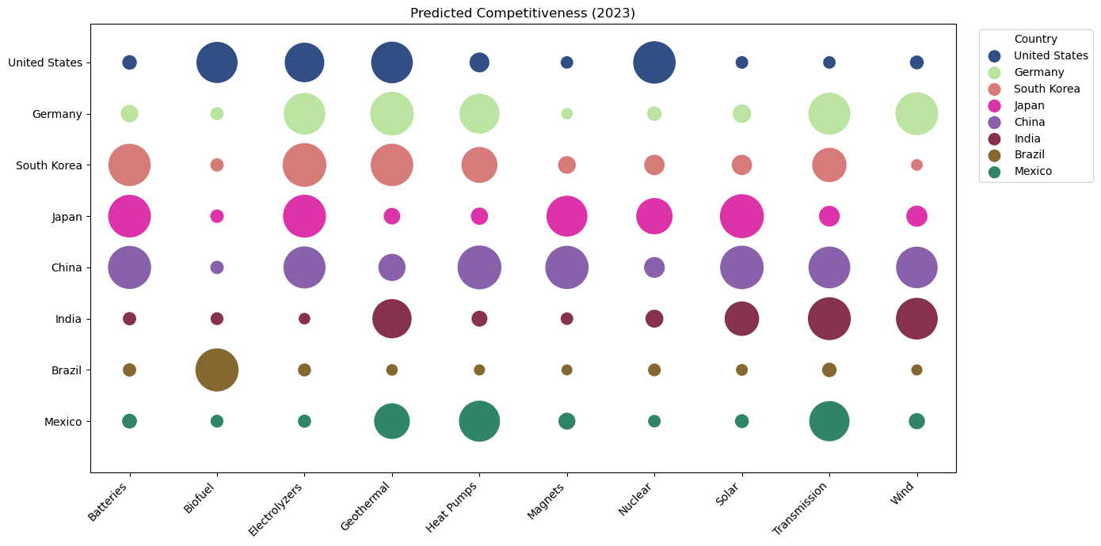
Thailand might easily conclude that it has strengths in electrolyzers and transmission it might like to boost. The model provides tools for doing so. One could easily interpret the results in a mechanical way. For example, to be competitive in electrolyzers, a country could aim to develop germanium oxides & zirconium dioxide exports—the top predictor for electrolyzer competitiveness. To compete in batteries, a country could build an export sector in flat-rolled steel coated with chromium, the top predictor there. However, this would be applying a false level of precision to the model and misinterpret its implications.
Instead, we can have confidence in the simpler, but more elegant finding that the knowledge and capabilities required to succeed in industrial development differs across technology areas. A comprehensive approach to building these capacities in focused areas is more likely to succeed.
The model is subject to further limitations. The dependent variable is whether or not a country is a competitive exporter of the final product, which does not tell us whether value-added manufacturing is happening in the economy. Re-exports could confound some of the results. We expect this to be a limited problem, but it may help explain the overperformance of some countries. Cross-referencing the results with granular production or value-added data at the country level, not possible in a universal study like this, would be advisable before designing industrial strategy on the results.

Conclusion
The goal of green industrial policy is to secure a country's position in global value chains and support the creation of innovative, competitive ecosystems at home. To do that, countries need to build on their strengths without remaining bound by the status quo.
Our model aims to balance future orientation with a realistic assessment of existing strengths. It helps countries identify sectors in which there are the greatest opportunities for competition. Beyond specific opportunities, it also identifies which parts of the industrial base drive predicted competitiveness. Thus, it can help identify where investments in the industrial base might benefit long-term export capability.
It does this by presenting a simple mapping of the five core capabilities needed to compete in clean energy technologies: electronics, machinery, mining and metals, industrial materials, and chemicals. This finding appears to support new work on industrial policy that suggests that states who invest in core, upstream capabilities are most likely to succeed.
The detail in country-level advice could also be improved by running the model at each stage of the supply chain, so that competitiveness in key components could also be ranked. This is important because the more specific industrial policy targeting is, the easier it is to build supportive ecosystems.
Another important extension is to understand the policy determinants of competitiveness. Which industrial and trade policies are most likely to improve competitiveness? Understanding the effectiveness of various policy tools will be critical for countries success.

We provide descriptive statistics for all technologies’ key predictors in Supplementary Information Tables SI.15-SI.24.
Meckling et al; Allan et al, GIP; Allan and Nahm; Juhasz, Lane, and Rodrik.
Nahm 2021.
César A. Hidalgo, Bailey Klinger, A-L. Barabási, and Ricardo Hausmann. "The product space conditions the development of nations." Science 317, no. 5837 (2007): 482-487.
Berger 2013; Breznitz 2021.
Rosenow and Mealy; Mealy and Tietelbaum 2022
A.H. Amsden, Asia’s Next Giant (New York: Oxford University Press), 1989; Ernest Liu, “Industrial Policies in Production Networks,” Quarterly Journal of Economics (2019); Nathan Lane, "Manufacturing revolutions: Industrial policy and industrialization in South Korea," The Quarterly Journal of Economics (2025).
U.S. International Development Finance Corporation, “DFC Announces Approval to Provide up to $500 Million of Debt Financing for First Solar’s Vertically-Integrated Thin Film Solar Manufacturing Facility in India.” https://www.dfc.gov/media/press-releases/dfc-announces-approval-provide-500-million-debt-financing-first-solars

